**Guided By:**

**Dr. Karthika Natarajan**

# Table of Contents

1. **Event Details Queries**
   * Insert a new event
   * Retrieve all events
   * Retrieve a specific event by eventId
   * Update the capacity of an event
   * Delete an event by eventId
   * Find events scheduled on a specific date
   * Retrieve events with capacity greater than a certain number
   * Count the number of events
   * Add a new field (organizer) to an event
   * Remove a field (description) from an event

# Attendee Queries

* + Add a new attendee
  + Retrieve all attendees
  + Find an attendee by email
  + Update attendee information (change email)
  + Delete an attendee by attendeeId
  + Add an event to an attendee's registration list
  + Remove an event from an attendee's registration list
  + Count the total number of attendees
  + Find attendees registered for a specific event
  + Update multiple attendees to add a new event

# Schedule Queries

* + Insert a new schedule entry
  + Retrieve all schedules for a specific event
  + Update the speaker for a session
  + Delete a schedule entry
  + Count the number of schedules for a specific event

# Ticketing Queries

* + Insert a new ticket
  + Retrieve all tickets for an event
  + Update ticket type for a specific ticket
  + Delete a ticket by ticketId
  + Count the number of tickets sold for an event
  + Find tickets for a specific attendee
  + Retrieve tickets with a price greater than a certain amount
  + Add a discount to a specific ticket
  + Remove a discount from a specific ticket
  + Update multiple tickets for a price change

# Real-Time Updates Queries

* + Insert a new update notification for an event
  + Retrieve all notifications for an event
  + Delete a notification by notificationId
  + Count the number of notifications for a specific event
  + Update the message of a notification
  + Insert a real-time attendee check-in record
  + Retrieve all check-in records for an event
  + Update the check-in time for a specific record
  + Delete a check-in record by checkinId
  + Count the number of check-ins for an event
  + Find check-ins for a specific attendee
  + Insert a real-time event feedback entry
  + Retrieve all feedback for an event
  + Update the rating and comment for a feedback entry
  + Delete a feedback entry by feedbackId
  + Retrieve feedback with ratings greater than a certain number

# Vendor Queries

* + Insert a new vendor record for an event
  + Retrieve all vendors for an event
  + Update the service type for a vendor
  + Delete a vendor by vendorId
  + Count the total number of vendors for an event

# Incident Reports Queries

* + Insert a real-time incident report for an event
  + Retrieve all incidents for an event
  + Update the description of an incident
  + Delete an incident report by incidentId
  + Count the number of incidents reported for an event

# Sponsor Queries

* + Insert a sponsor record for an event
  + Retrieve all sponsors for an event
  + Update the contribution amount for a sponsor
  + Delete a sponsor by sponsorId
  + Count the number of sponsors for an event

# Parking Reservations Queries

* + Insert a new parking reservation for an event
  + Retrieve all parking reservations for an event
  + Update parking spot for a reservation
  + Delete a parking reservation by reservationId
  + Count the number of parking reservations for an event

# Security Updates Queries

* Insert a security update record for an event
* Retrieve all security updates for an event
* Update the message for a security update
* Delete a security update by updateId

USE CASE:

# Overall System:

* The system facilitates event management and related operations.

# Attendee:

* Can browse events.
* Can register for an event.
* Can review an event.
* Can cancel an event.

# Event Organizer:

* Can create an event.
* Can manage events.
* Can edit events.
* Can view attendees.

# Admin:

* Can generate reports.
* Can configure system settings.
* Can manage users.
* Can handle security & authentication.

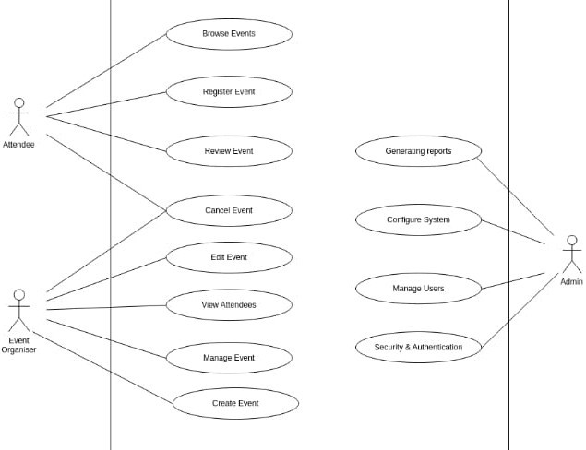

Collection names: events, attendees, schedules, tickets

1. 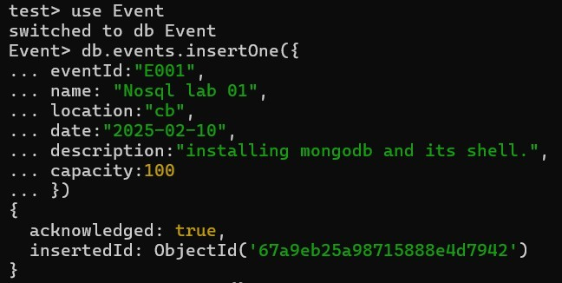Insert a new event
2. 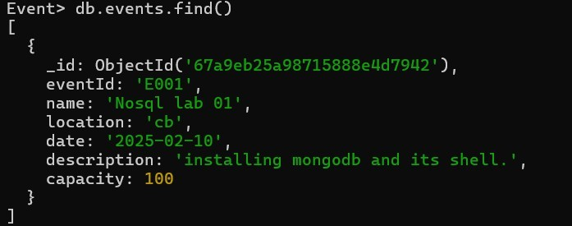Retrieve all events
3. 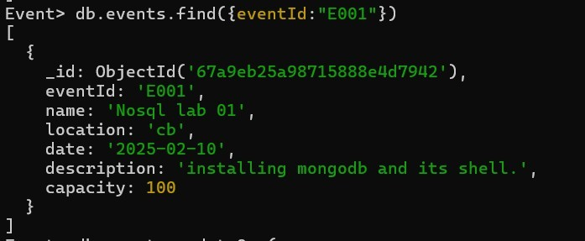Retrieve a specific event by eventId
4. 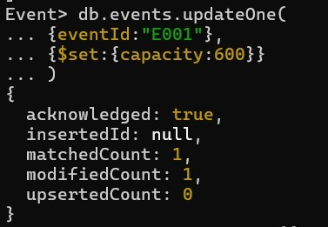Update the capacity of an event
5. Delete an event by eventId
6. Find events scheduled on a specific date



1. 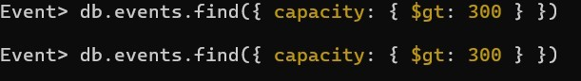Retrieve events with capacity greater than 300
2. Count the number of events in the database
3. Add a new field (organizer) to an event

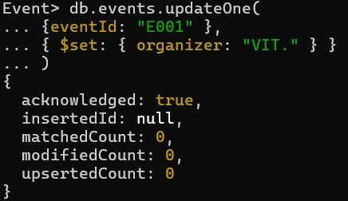

1. 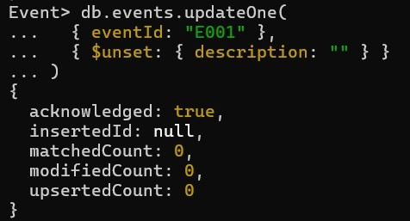Remove a field (description) from an event

ATTENDEE QUERIES

1. 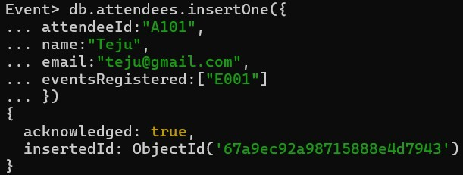Add a new attendee
2. Retrieve all attendees

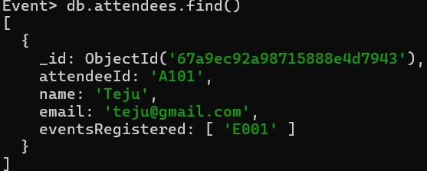

1. 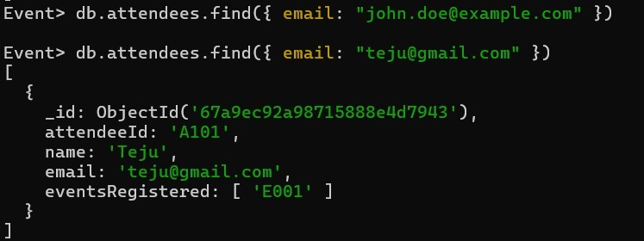Find an attendee by email
2. 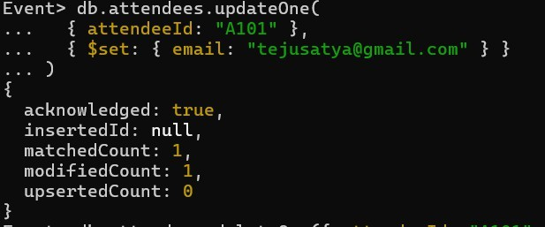Update attendee information (change email)
3. Delete an attendee by attendeeId
4. Add an event to an attendee's registration list

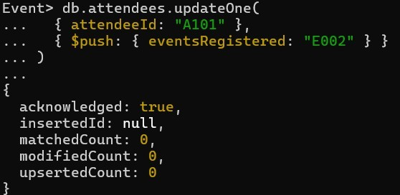

1. Remove an event from an attendee's registration list

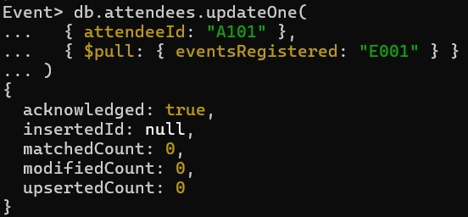

1. Count the total number of attendees
2. Find attendees registered for a specific event



1. Update multiple attendees to add a new event

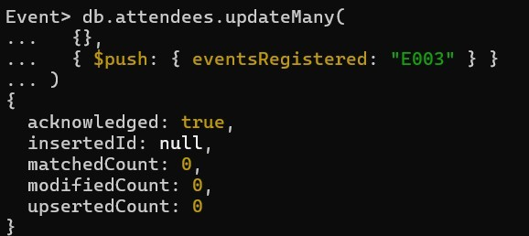

SCHEDULE QUERIES

1. 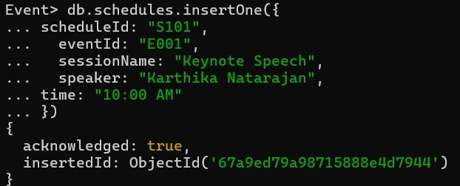Insert a new schedule entry
2. 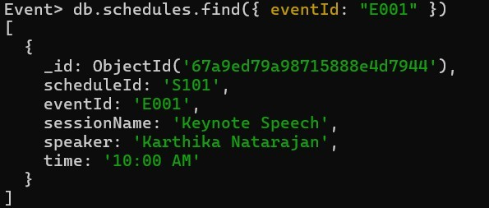Retrieve all schedules for a specific event
3. Update the speaker for a session

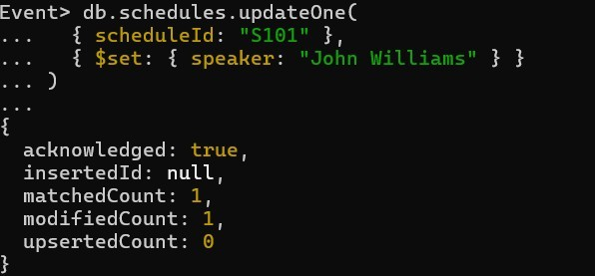

1. Delete a schedule entry
2. Count the number of schedules for a specific event

TICKETING QUERIES

1. 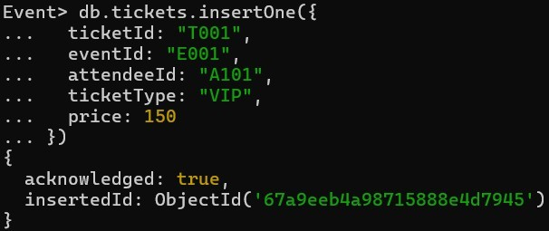Insert a new ticket
2. Retrieve all tickets for an event

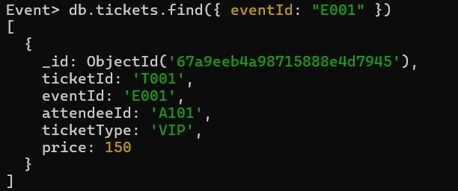

1. 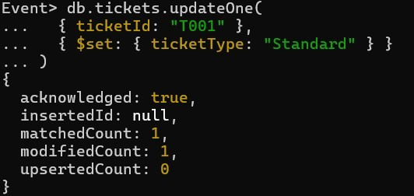Update ticket type for a specific ticket
2. Delete a ticket by ticketId
3. Count the number of tickets sold for an event
4. Find tickets for a specific attendee



1. Retrieve tickets with a price greater than $100
2. 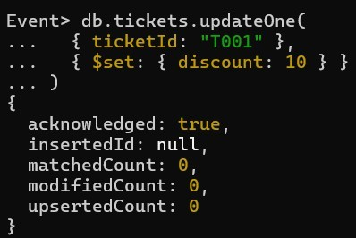Add a discount to a specific ticket
3. 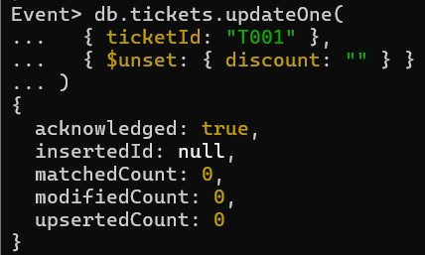Remove a discount from a specific ticket
4. 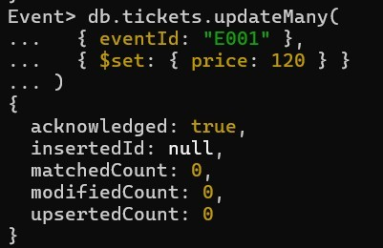Update multiple tickets for a price change

REAL-TIME UPDATES QUERIES

1. Insert a new update notification for an event

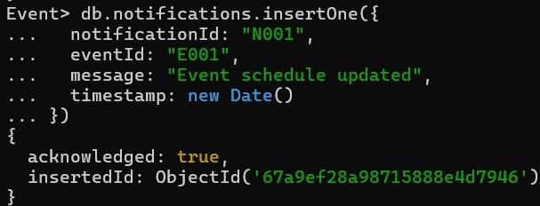

1. 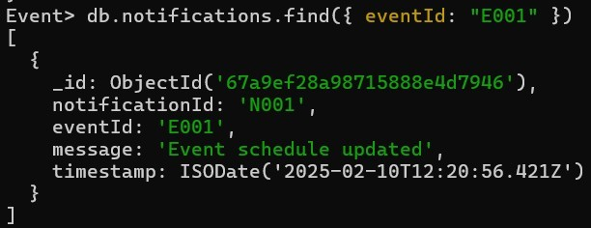Retrieve all notifications for an event
2. Delete a notification by notificationId
3. Count the number of notifications for a specific event



1. Update the message of a notification

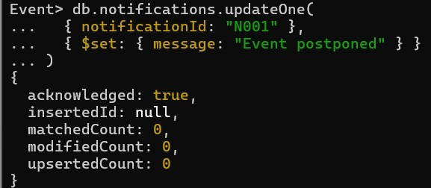

1. 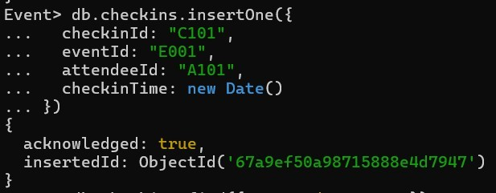Insert a real-time attendee check-in record
2. 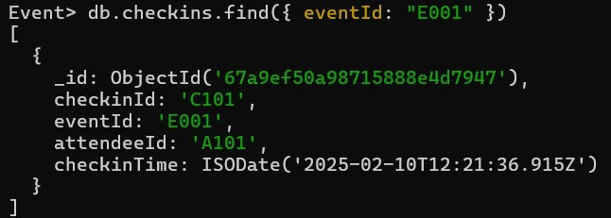Retrieve all check-in records for an event
3. Update the check-in time for a specific record

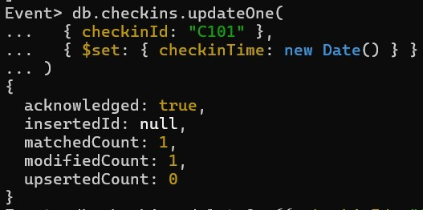

1. Delete a check-in record by checkinId
2. Count the number of check-ins for an event
3. Find check-ins for a specific attendeeID



1. 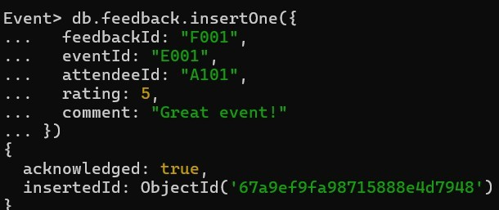Insert a real-time event feedback entry
2. Retrieve all feedback for an event

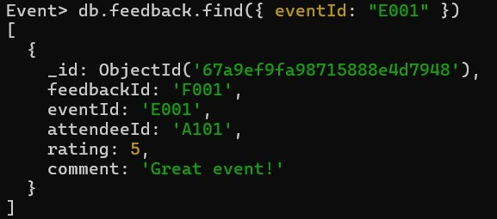

1. 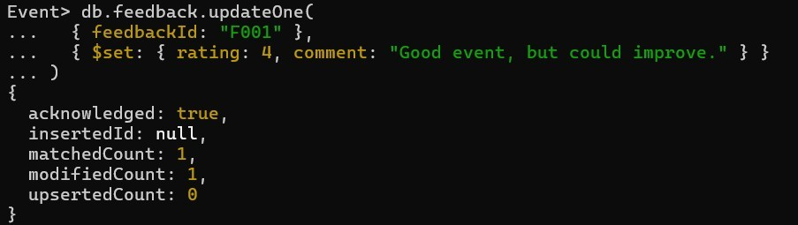Update the rating and comment for a feedback entry
2. Delete a feedback entry by feedbackId
3. Retrieve feedback with ratings greater than 3
4. 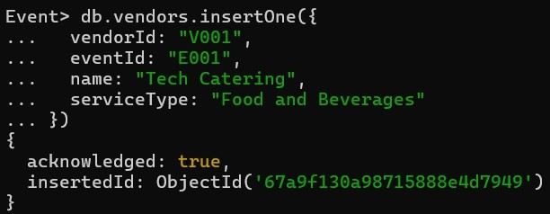Insert a new vendor record for an event
5. 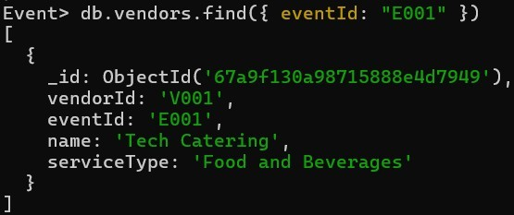Retrieve all vendors for an event
6. 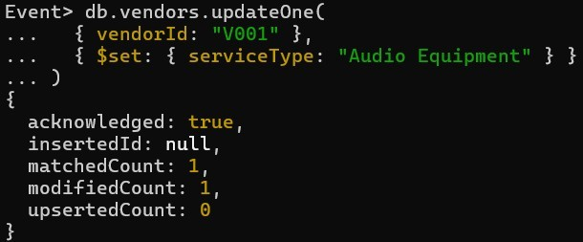Update the service type for a vendor
7. Delete a vendor by vendorId
8. Count the total number of vendors for an event
9. Insert a real-time incident report for an event

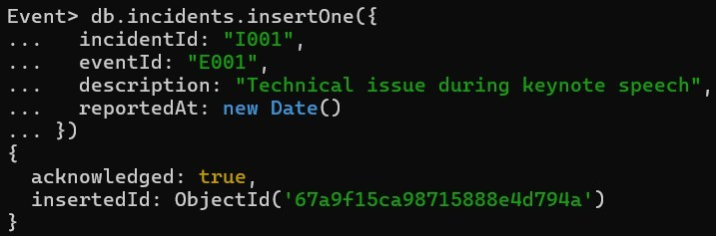

1. 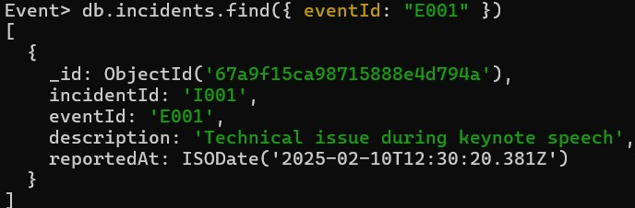Retrieve all incidents for an event
2. 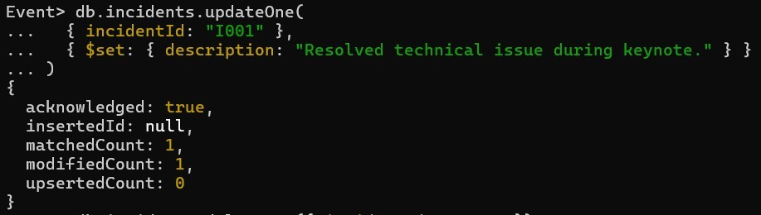Update the description of an incident
3. Delete an incident report by incidentId
4. Count the number of incidents reported for an event



1. 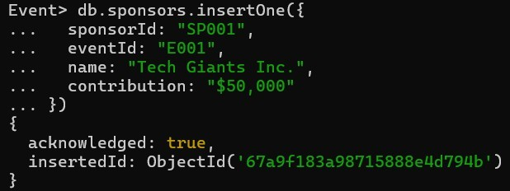Insert a sponsor record for an event
2. 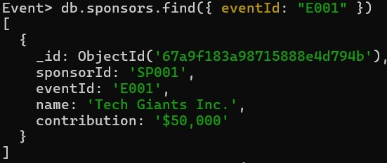Retrieve all sponsors for an event
3. 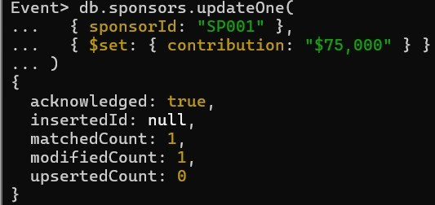Update the contribution amount for a sponsor
4. Delete a sponsor by sponsorId
5. Count the number of sponsors for an event



1. 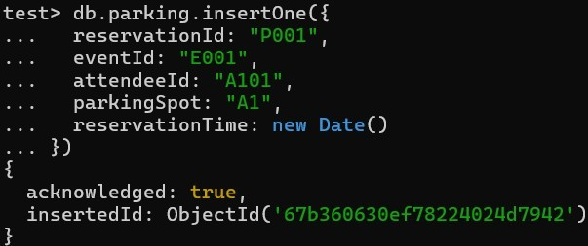Insert a new parking reservation for an event
2. 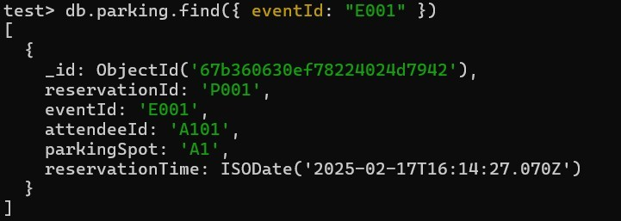Retrieve all parking reservations for an event
3. 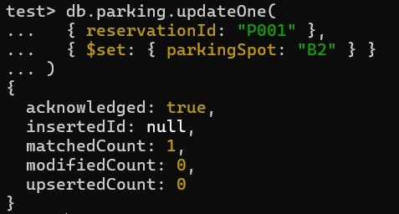Update parking spot for a reservation
4. Delete a parking reservation by reservationId



1. Count the number of parking reservations for an event



1. 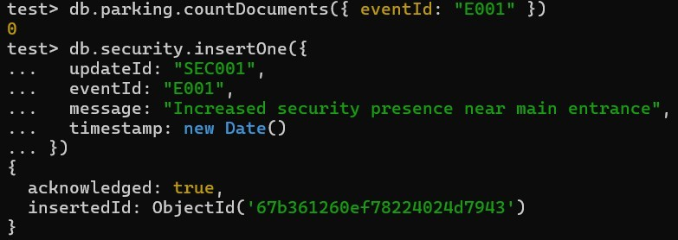Insert a security update record for an event
2. 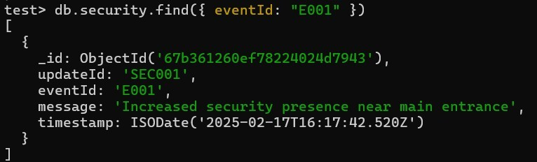Retrieve all security updates for an event
3. Update the message for a security update
4. 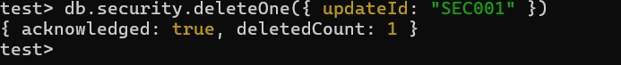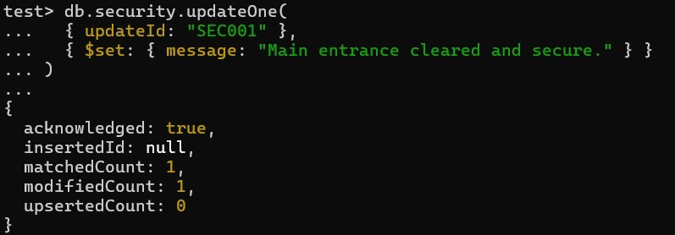Delete a security update by updateId